**Approvals Template**

**2021.05.17**

Contents

Introduction

Screen description

* Main ( Requester )
* Main ( Approver )
* Job ( Requester )
* Review ( Requetser, Approver )
* Noti ( Requester, Approver )
* MyProfile ( Requester, Approver )
* Account ( Admin )
* MenuLayout ( Requester, Approver, Admin )

Extensibility

Usability

Introduction

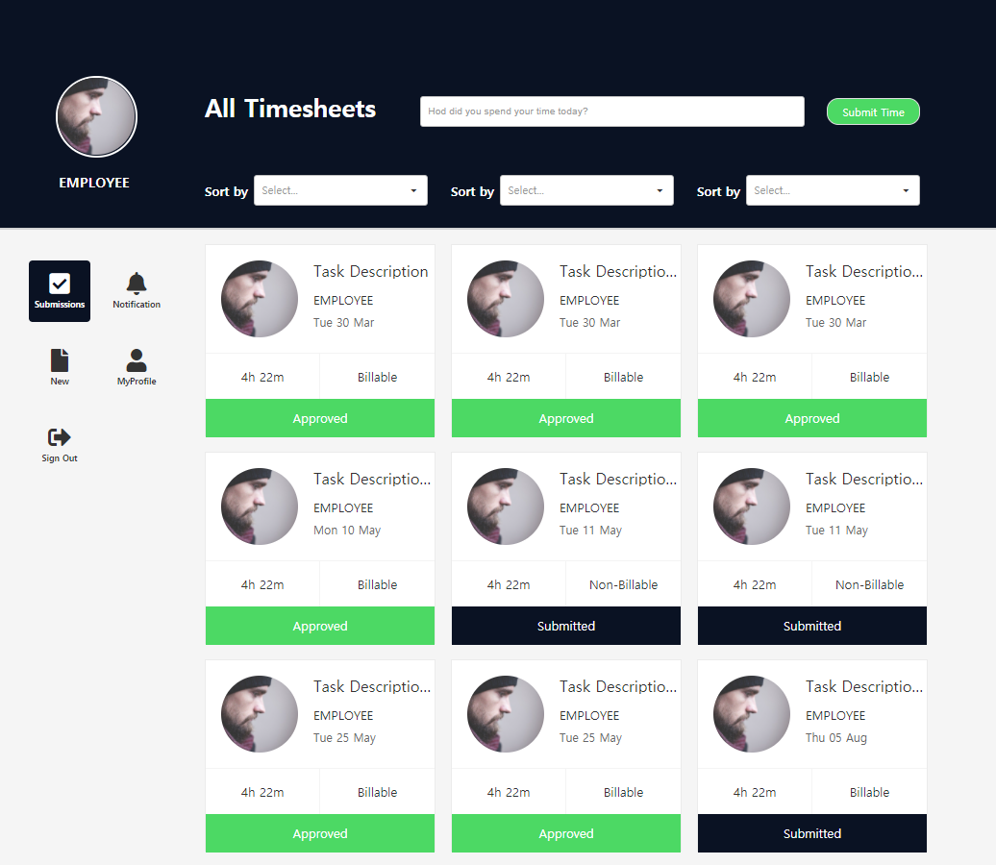

This template is a template for reporting and approving billing hours to decision makers.

An employee submits a job to Approver, and Approver can approve or reject it.

Screen description

1. Main ( Requester )

* Related object : MainWForm, MainWESet, JobRSet
* This is the main screen that your Emplyoee account sees. Displays a list of billing hour jobs submitted by Emplyoee. Submitted results are displayed in three categories: Submitted, Approved, and Declined. You can search the list according to conditions, and click to check detailed information.

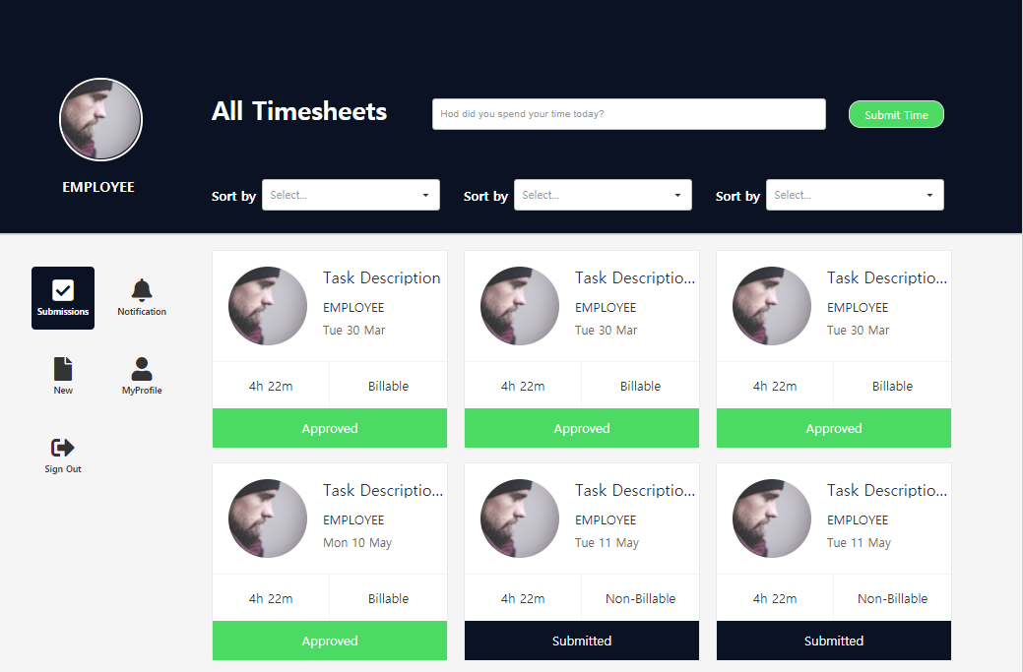



: Button to move to the screen where you can write billing hour. You can move to the writing screen while entering the description in the textBox.



: Option to search the list (date, submission result, billing hour or not)

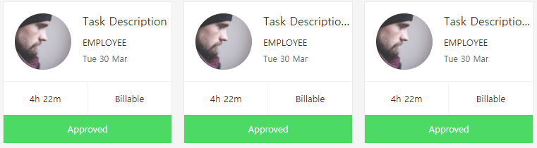

: Billing hour list (Click to view detailed information)

1. Main ( Approver )

* Related object : MainWForm, MainWESet, JobRSet
* This is the main screen that your Apporver account sees. Displays billing hour job list submitted to Approver. You can approve or reject the submitted job by clicking the list. The processed result can be changed again.
* 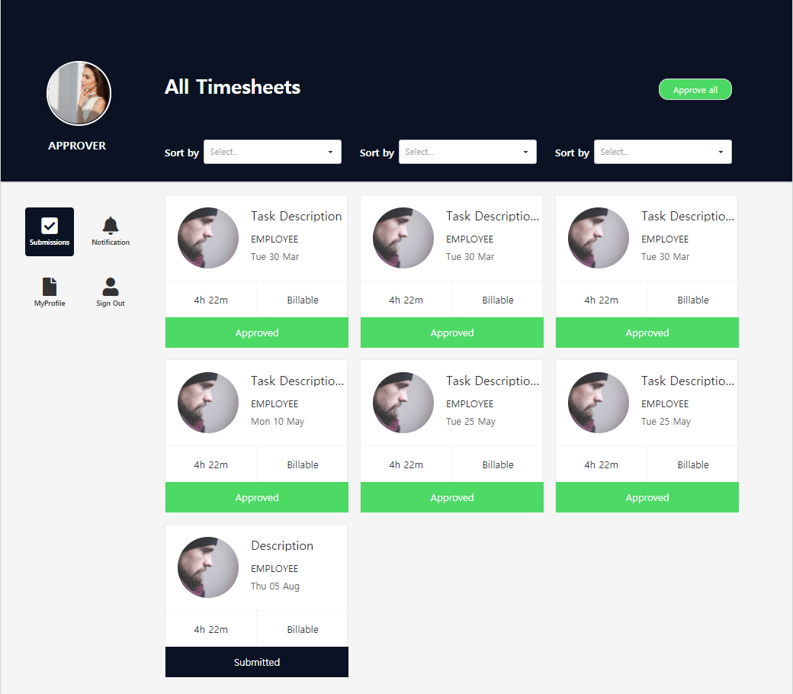

 : Button to approve all jobs.



: Option to search the list (date, submission result, billing hour or not)



: Billing hour list (Click to approve or reject)

1. Job ( Requester )

* Related object : JobWForm, JobWESet, JobRSet
* This is the screen to create a billing hour job. Fill out the detailed information and submit it to the target Approver. It is also a screen where detailed information can be checked when a list item is clicked on the Employee main screen.

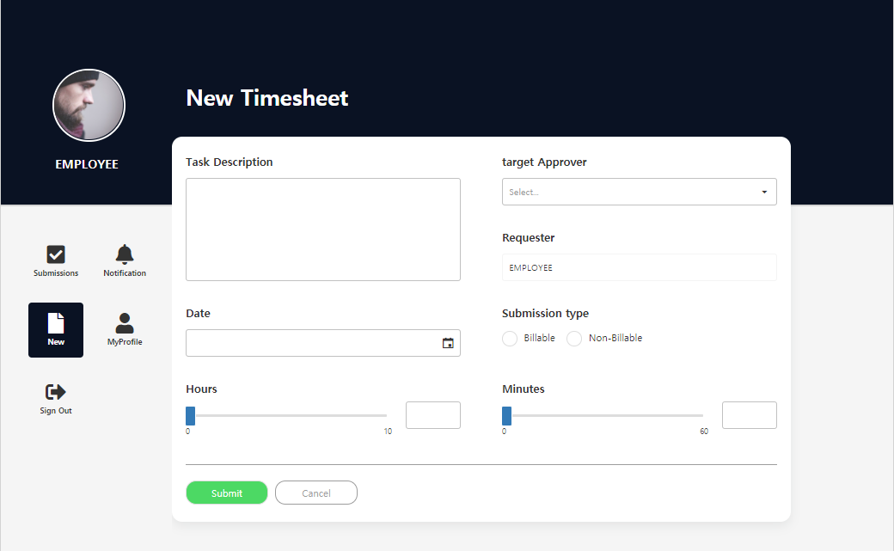

 : Submit and go to main screen buttons

1. Review ( Requester, Approver )

* Related object : ReviewWForm, ReViewWESet, JobRSet
* This is a screen that both emplyoee and approver can see. The approver is a screen that you can see when you click the job list submitted to you. The approver can approve or reject by writing the review details below. employee is the screen you see when you click on an approved or rejected job. You cannot write reviews, you can only view them.

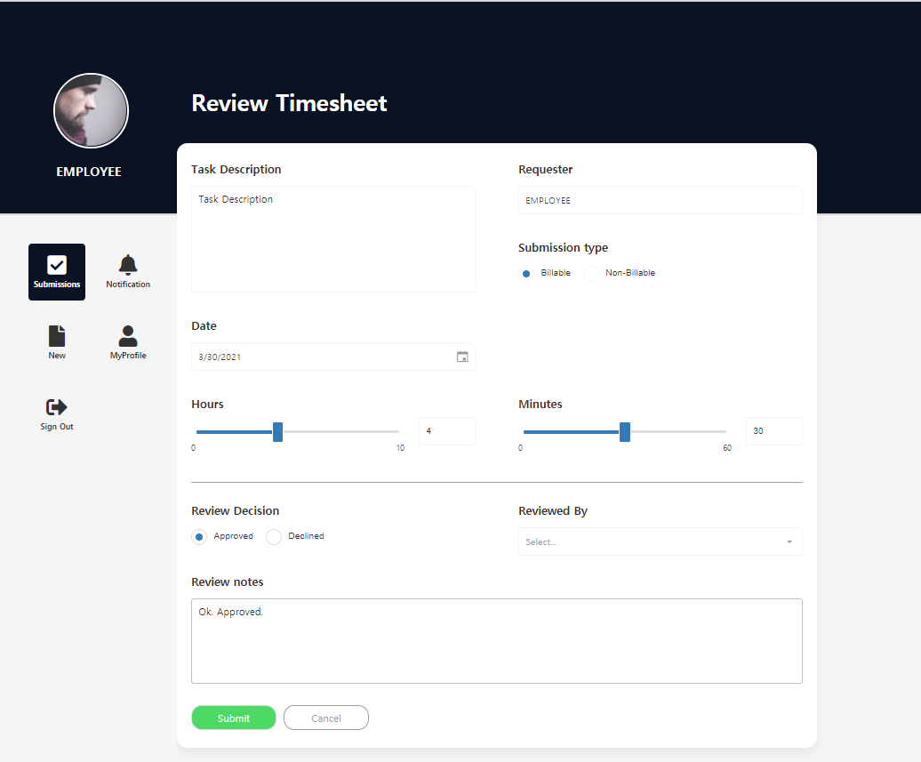

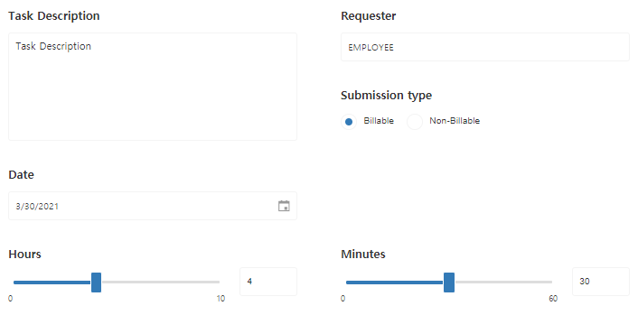

: Contents of the created job (view only)

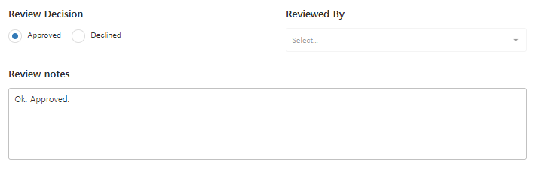

: Content written by Approver when approval or rejection is processed (Requester can view only)

 : Submit and Cancel button (Only Approver can submit.)

1. Noti ( Requester, Approver )

* Related object : NotiWForm, NotiWESet, NotiRSet
* This is a screen that both emplyoee and approver can see. When an employee submits to the approver and the approver approves or rejects them, notifications are sent to each other. You can delete notifications and check detailed information of related jobs.

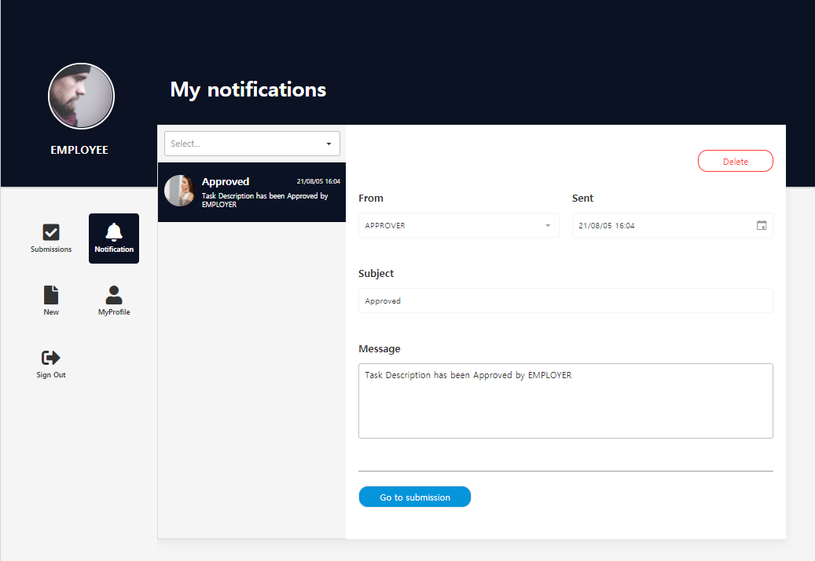

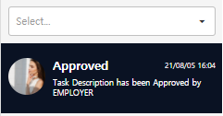 : Notification history can be sorted by date through selectBox.

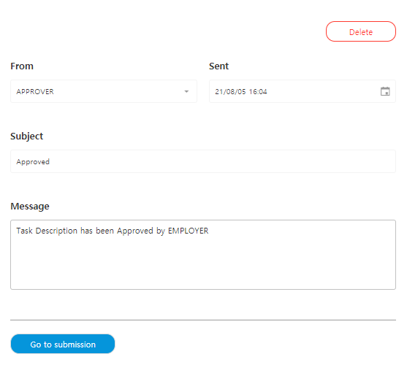

: The details of the notification can be deleted through the delete button, and it moves to the reviewWForm of the related job through the go to submission button.

1. MyProfile ( Requester, Approver )

* Related object : MyProfileWForm, MyProfileWESet, MyProfileRSet
* This is a screen that both emplyoee and approver can see. This is the screen where you can change account profile information.

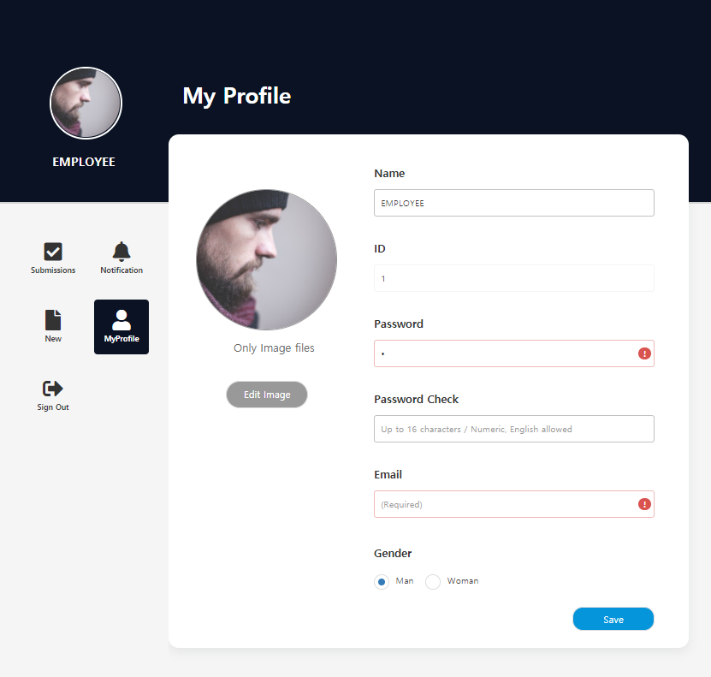

1. Account ( Admin )

* Related object : AccountWFrom, AccountWESet, MyProfileRSet
* This is the screen you see when you log in with an administrator account. You can edit or delete registered accounts and register new accounts. When creating a new account, you must log in and change the rest of your profile information.

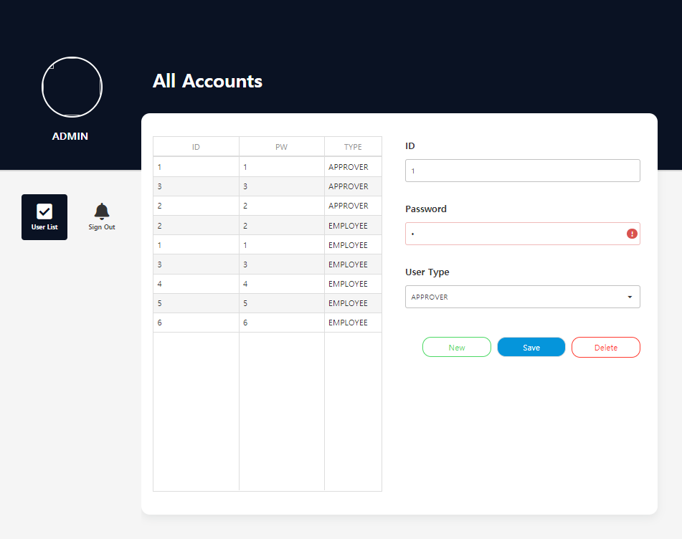



: Input box reset button, account edit, delete button

1. MenuLayout ( Requester, Approver, Amdin )

* Related object : MenuLayourtWForm, LoginWESet
* This is a common layout form for all accounts. Displays the login user's information and menu list. Each account has a different menu configuration.





: Display the login user's image and name

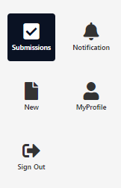

: MainWForm, NotiWForm, JobWForm, MyProfileWForm

Extensibility

1. simply

* Add Review Information
* Search by date on the main screen
* etc guideline

1. Difficultly

* Added billable and non-billable statistics screens by Employer

Usability

* Vacation management
* Add department and add billing hour comparison screen by department